A Project on

New Zealand Based Library

# Introduction

New Zealand Based Library is developed to help staff to organize the library information and materials and also providing materials to students in an organized manner. This system consists of Front-End of the system in which I have developed mainly three pages for the sites home page which means landing page consisting landing image, description contents and contact section, login page which helps user to login into the admin panel and the last one is admin page which shows the back-end data to the user.

The main aim of the project are:-

1. Converting the manual system of library management into organized web based system.
2. Securing library data and maintaining and managing data to analyze books information.
3. Helps to provide staff a organize information and also helps students easily to know about the library books and materials.
4. Managing inventory, analyzing data etc.

# User Guides

The system is mainly divided into three pages. They are landing page (home page), login page and admin page.

## Home page (Landing Page)

This page is also called index.html page which is landing page of the system when user entered into the site, he/she will be redirected to this page.

How this page looks like?

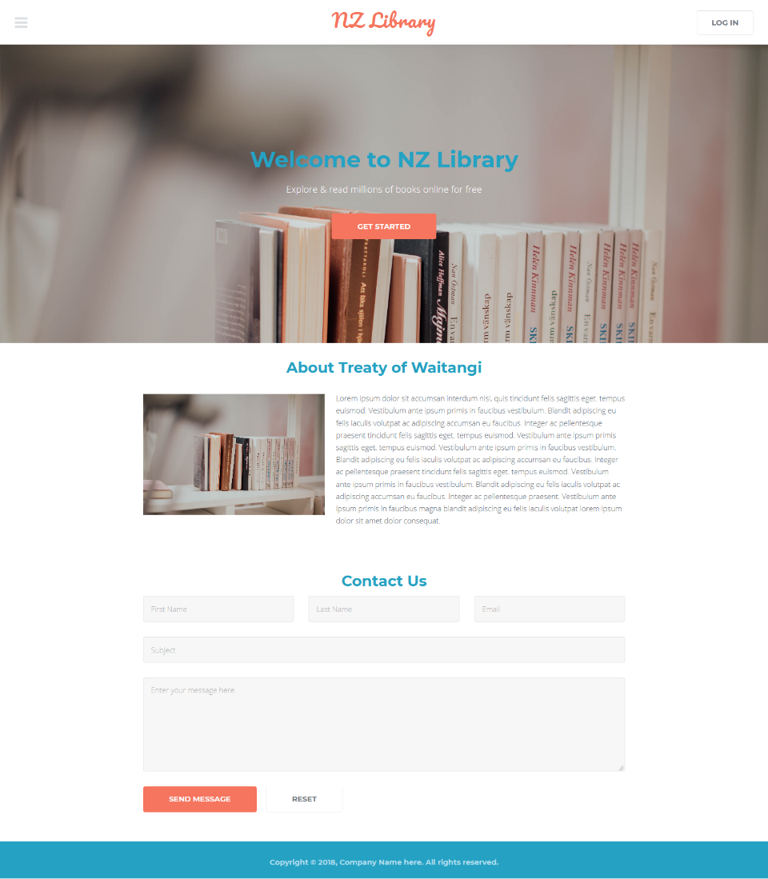

In this page, there is navbar on the top of the page which consist Login button using which we can go to login page (login.html) where we can log into the system using credentials (username and password).

First section is landing image and containing few sentence over it. Second section is about section which tell about the system or provide descriptions.

Third Section is Contact Section from which visitor or user can contact to the administrator of the site. This section consists First Name, Last Name, Email, Subject, and Message and also consists of two buttons, one for Send Message and another for Reset.

Send Message button will send the information whereas Reset button resets or clears the data entered by the user.

The final or bottom section is footer which is the section for every pages.

* 1. **Login Page**

Login Page is used to log into the system providing credentials (username and password). If the username and password is correct then user is redirected to admin panel otherwise "Credentials does not match our records" message is printed on the screen.

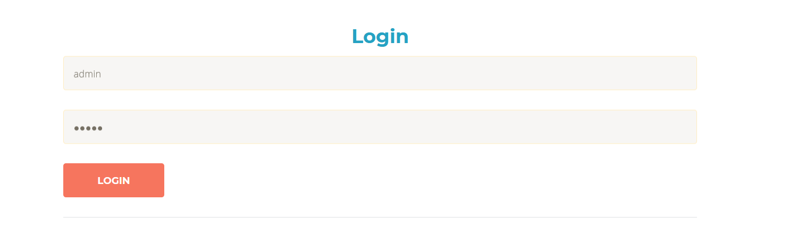

Here, to log in to the system, you must enter username and password and if that match the credentials records then you will be redirected to the admin panel (admin.html).

* 1. **Admin Page**

Admin Page is redirected only if the user is logged in to the system from login page. This page consist of mainly three sections. They are Library Registered Books, Students and Popular Literature.

Library registered books consists of registered books with their basic information book name, due date and view books.

Students section consists of students profile with name and faculty. The last section consist of popular literature containing the book name, author, year, rank, and status of the books and materials.

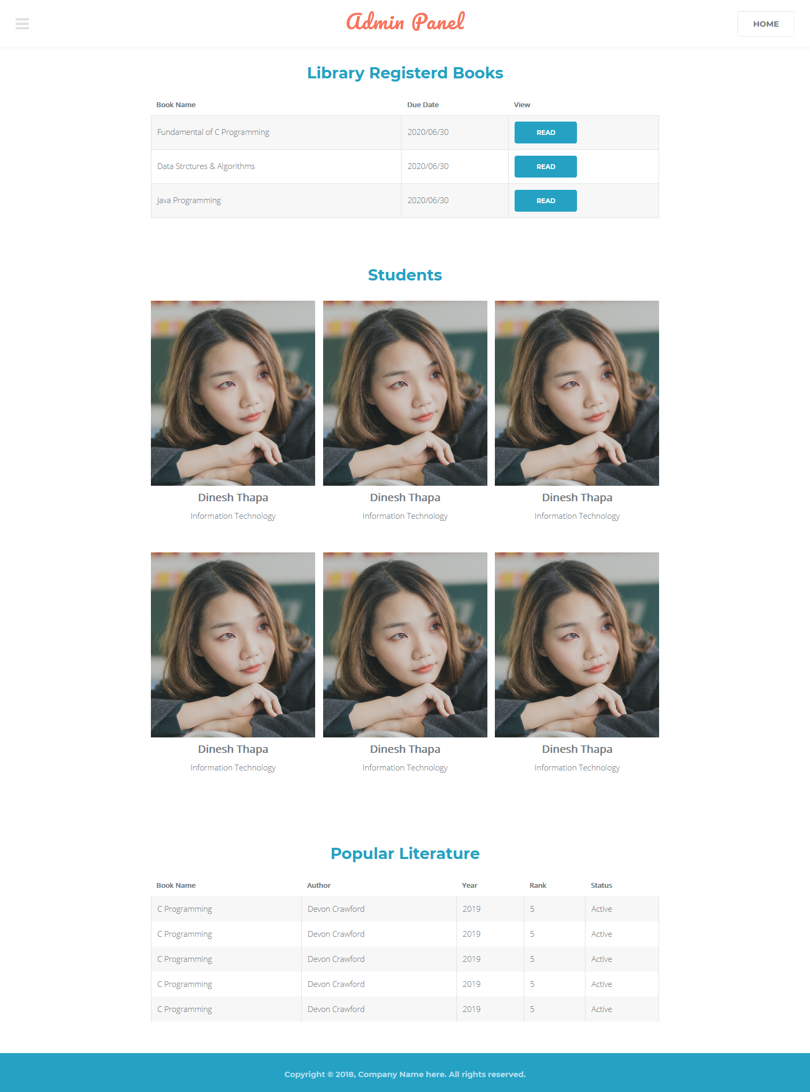

# References

chuttersnap. (2019, February 9). Landing Image. Singapore.

Fonticons, I. (n.d.). *Font Awesome.* Retrieved from Font Awesome: https://fontawesome.com/

Jquery. (n.d.). *Jquery*. Retrieved from https://jquery.com/

JS, S. (n.d.). *Skel JS*. Retrieved from Skel JS: https://github.com/ajlkn/skel/tree/master/src

Kong, S. (2017, December 27). Student Photo. Shenzhen, China.

Text, L. (n.d.). *Lipsum.* Retrieved from Lorem Ipsum: https://www.lipsum.com/